General-Type Purchase Orders: This topic will walk you through how to create, manage, and ultimately close out General-Type Purchase Orders (POs). This PO Type is the most basic type available, and as such can be used for ordering nearly anything, like furniture, office supplies, cleaning products, tools for the Service department, etc. However, you should not use this type if using Integrated Purchase Orders (IPO) to order units or parts, as we have specific PO types designed to handle the in-system accounting that comes with those orders.

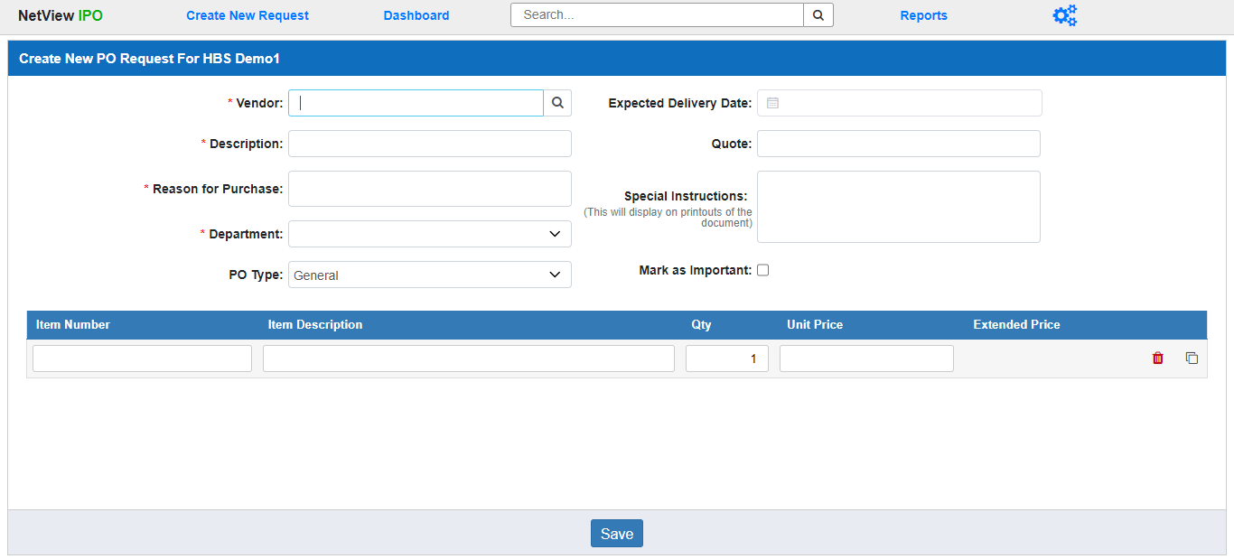

Create New General PO Request: To begin, a user with a Buyer role must create the new General purchase request in IPO. Click on Create New Request in the IPO Program Header. The screen above will open. Fill in the required information to create your request.

Vendor: Enter the full vendor number for the request, or use the Vendor Lookup to find the vendor if you don’t know the full number, or only know the vendor’s name. This is a required field, and the vendor must already exist in the system (if you need to add them in Vendor Maintenance (VIM), do it before creating the request).

Description: Enter a description for the request. This will serve as an additional identifier for the order when you look for it on the Dashboard or the IPO Document Search. This is a required field.

Reason for Purchase: Enter the reason you want to make this purchase. This is a required field.

Department: Use the drop-down menu to select which department you are making the request for. This is a required field. The options will consist of the 7 standard departments—Administration, Inventory, Rental, Sales, Service, Transport, and Wholegoods—as well as any custom departments your dealership has added to the system.

PO Type: Select General as the PO Type. This will set the Add Line Grid below to record General Type line items (see below for details).

Expected Delivery Date: If you have an idea what the order’s expected delivery date might be, you can enter it in this optional field or select it from the calendar.

Quote: If you have a quote number to go with your request, enter it in this optional field.

Special Instructions: You can use this optional field to add a special delivery note to the request, if desired. These instructions will then display on printouts of the document.

Mark as Important: If you want to mark the request as “Important,” essentially flagging it as a priority item for other roles that will work on it, check this box. This will mark the document’s entry in the columns on the Column Dashboard View with an “Important” indicator (a red circle with an exclamation mark inside).

Add Line Grid: Having selected General as the PO Type, the Add Line Grid at the bottom of the screen will be formatted specifically to add General-Type line items to the purchase request. Fill in the fields to create the line. Once you go through the first line, a new line will appear automatically. Add as many line items as needed for your request.

Item Number: This field holds the vendor-assigned item number.

Item Description: This field hold the item description.

Qty: Enter the item quantity you want to order. This field will always default to 1.

Unit Price: Enter the unit price, or price per individual item, in this field.

Extended Price: This is a display field only. It will auto-fill with the full price of the line item (Quantity X Unit Price) once you add the quantity and the unit price.

Delete: If you want to remove a line after filling it out, or if you have accidentally generated an unneeded line, click the icon of a red trash can at the far right end of the line. This will delete the line.

Clone: If at any point you want to completely duplicate a line item, click the icon on the far right end of the line. This will generate a duplicate of the line directly below it in the grid, which you can modify if needed.

Save: Once you have filled in the required fields and added the line items you want to include, click this button to generate your request as a Requisition document.

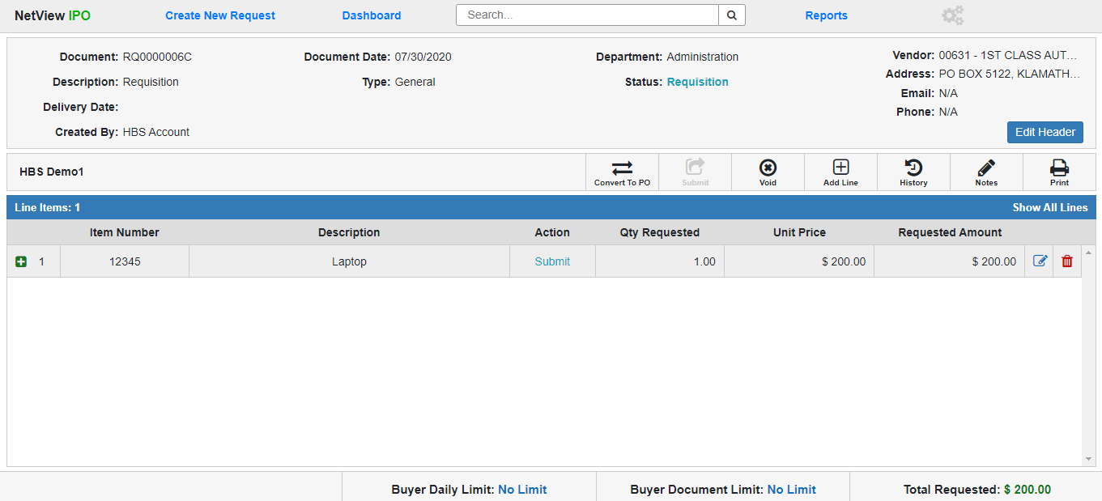

Open General Requisition: The Open Requisition document screen allows users to edit the Requisition before converting it into a Purchase Order (at which point most of the document will be locked for editing). A user can only make modifications to an Open Requisition if they are a Buyer for the Requisition’s assigned department at the location where the Requisition was created.

Requisition Header: The Header section provides basic information about the entire document. Click the Edit Header button to edit the Header fields. As you can see from the image below, only the fields you can actually edit will change when you click the button.

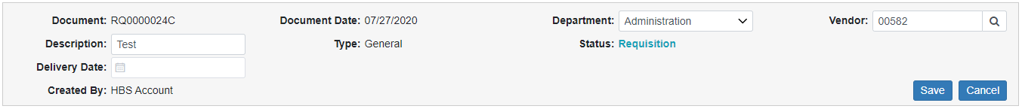

Document: This field shows the document number. It cannot be changed.

Description: This field shows the document description, which can be changed.

Delivery Date: This field can hold an expected delivery date for the purchase. If you obtain this information while the document is still a Requisition, you can add it here by entering it or using the calendar to select the date. You can also edit it at any time if the date changes before you convert the Requisition into a Purchase Order.

Created By: This field shows the user ID of the Buyer who originally created the Requisition. If you made the Requisition, your user ID will appear here. This field cannot be changed.

Document Date: This field shows the Requisition’s creation date. It cannot be changed.

Type: This field shows that the Requisition is a General-Type document. You cannot change the PO Type once you have set it during creation.

Department: This field shows the Requisition’s assigned document. Use the drop-down menu to change the document’s department. NOTE: You will only be able to select a department that your IPO role has permissions for.

Status: This field shows the document’s current status, which in this case will be Requisition.

Vendor: This part of the header will show you information about the document’s vendor, taken directly from the vendor record in VIM. As a result, if any of these fields indicate the information is not available, that is because it is not present in the vendor record. The fields show:

- Vendor Number and Name
- Vendor Address
- Vendor Email
- Vendor Phone Number

You can change the document’s vendor while it is still a Requisition, which will then automatically update the remaining information from the new vendor’s record.

Save: Click this button after modifying the header fields to save the new information and return the header to its display-only state.

Cancel: Click this button to return the header to its display-only state without saving any changes you may have made to the fields.

General Requisition Line Items: The grid below the header contains all the line items you added to the Requisition during creation, constructed as a main line and a subline with more information that you can view by expanding the line. If you want to expand all the lines at once, use the Show All Lines feature in the upper-right corner of the grid. The feature will change to Hide All Lines after you click it; click that to hide all the expanded lines again.

Main General Requisition Line Item: The main line items on General Type Requisitions show the following information:

- Line Number: Each line item has an assigned, unchanging number for record-keeping purposes. That number will appear here, and will be assigned in order of the line’s creation (first line created is 1, etc.).
- Item Number: This shows the line item’s item number.
- Description: This shows the item description.
- Action: This field shows the next action that needs to be done to the line. On an Open Requisition, this action will always be Submit, indicating that a Buyer needs to submit, or convert, the Requisition into a Purchase Order.
- Qty Requested: This field shows the quantity of the item requested by the Buyer.
- Unit Price: This field shows the item’s unit price.
- Requested Amount: This field shows the total amount requested for the line item, which is calculated by multiplying the Unit Price by the Qty Requested.
- Delete: If for any reason you need to remove a line item from a Requisition before making the document into a Purchase Order, click the red trash can icon on the far right of the line item. The following warning will appear:

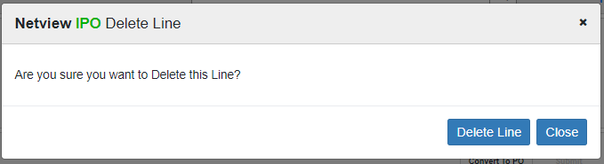

Click Delete Line to delete the line from the Requisition.

Edit General Line Item: If you need to edit a line item on a Requisition, click the icon on the far right of the line. The following screen will open:

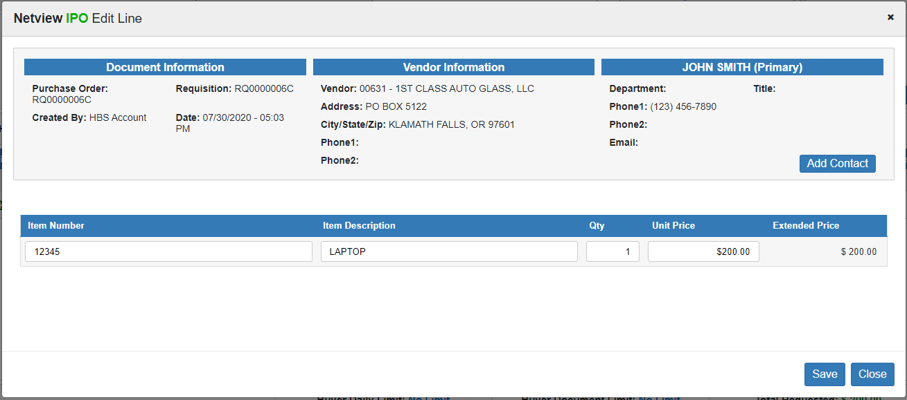

Make the edits you need, then click Save. The screen will close and the line item will be updated with the changes.

**FEATURE NOTE**: The Header section you see in the image above is a common feature that will appear in several screens related to working on Requisition or PO documents. It offers you a quick snapshot of the basic document information in the same way as the main Document Header, though it also allows you to add or edit the Vendor Contact associated with the document by sending you to the vendor’s page in Vendor Maintenance (VIM). If the vendor has a set contact, clicking Add Contact will send you to VIM and let you edit or change the contact. If the vendor does not, there will be a different link to VIM anyway allowing you to add one.

Expanded General Line Item: An expanded General line item on a Requisition will look like this:

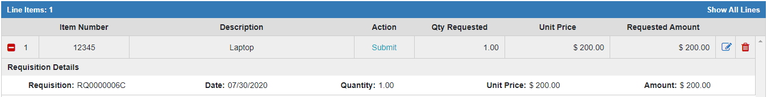

The Requisition Details holds line item’s Requisition information so that it will be preserved once the document becomes a Purchase Order.

- Requisition: This field shows the Requisition number.
- Date: This field shows the line item’s creation date. If the line was created during the initial document creation, this date will be the same as the Document Date.
- Quantity: This field shows the line item quantity.
- Unit Price: This field shows the line item’s unit price.
- Amount: This field shows the line item’s total requested amount.

General Requisition Footer: The Requisition footer (pictured above) shows how much money the Buyer has left to request before they hit their Daily and Document Limits, as well as the current Total Requested Amount for the Requisition, which updates whenever the total value of the document changes. This keeps the Buyer aware of their spending limits and if the current request would go over those amounts, forcing them to submit it to an Approver.

General Requisition Document Actions: The Document Actions Toolbar displays below the Document Header and above the Line Items Grid. These buttons represent actions that a Buyer can perform on the document.

Print: Click this button to print a copy of the Requisition. The following window will open:

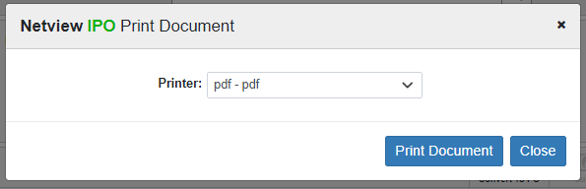

Select the printer to receive the document and click Print Document. Below is a sample Requisition printout:

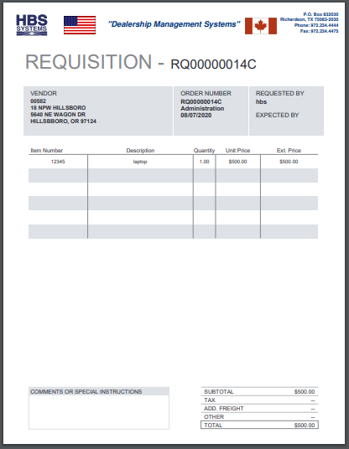

Notes: Click this button to view all notes attached to the document, along with what user created them and when.

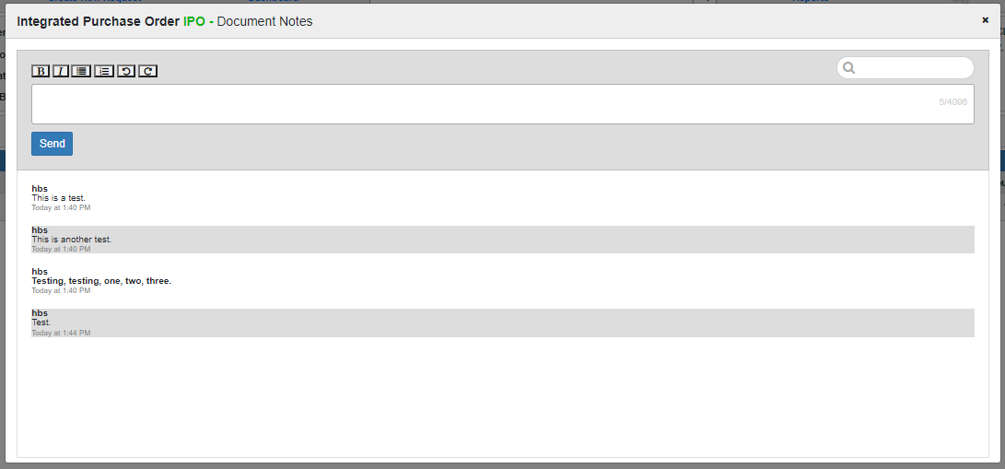

You can use the Search field at the top of the screen to filter the notes based on what you enter. Certain notes will also have tags indicating they were added to the document at specific points. For example, the note added in the Special Delivery Note field of the Create New Request screen will have a tag identifying it.

You can also add notes in this screen by entering the new note in the Add Note field below the Search and clicking Send. The screen also comes with standard text editing features so you can modify the note as desired (bold, underline, bullets, numbering, etc.).

History: Click this button to view the document’s history, which records all actions which have been performed on the document:

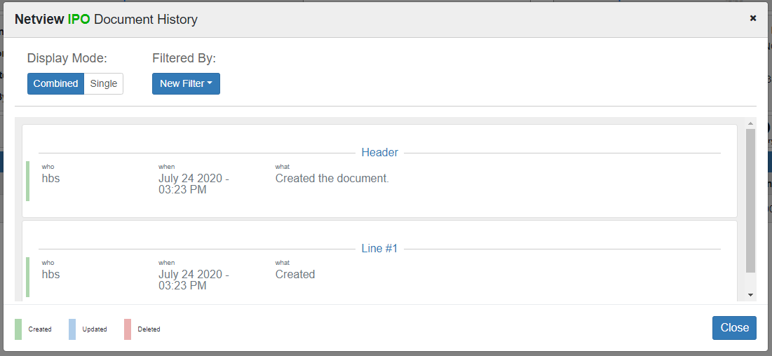

The program classifies each action based on what part of the document it was performed upon: the Header or a Line Item (identified by their Line Number). Each action is also color-coded as one of three action categories, as explained by the legend in the bottom left-hand corner of the screen:

- Created (green): represents the initial document creation
- Updated (blue): represents any changes to a document element
- Deleted (red): represents anything being removed from the document

There are two ways to display the document history. The first is the Combined display, pictured above, which groups all actions performed on a single document item together: all actions performed on the Header are listed together, all actions on Line #1 are together, etc.

You can use the Filtered By field if you want to only look at a specific grouping of document actions: select a document element from the dropdown (Header, Line #1, etc.), and the screen will automatically close all the sections except the one for that element:

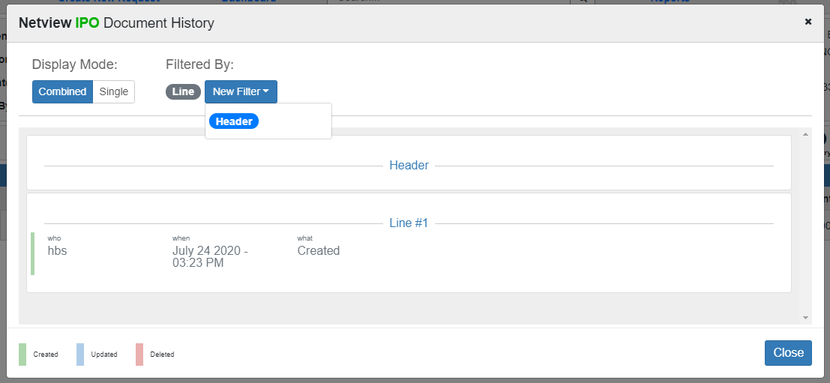

Click the filtered element again to clear it and reopen the other sections.

The other mode is the Single display, which displays all the actions in a single list:

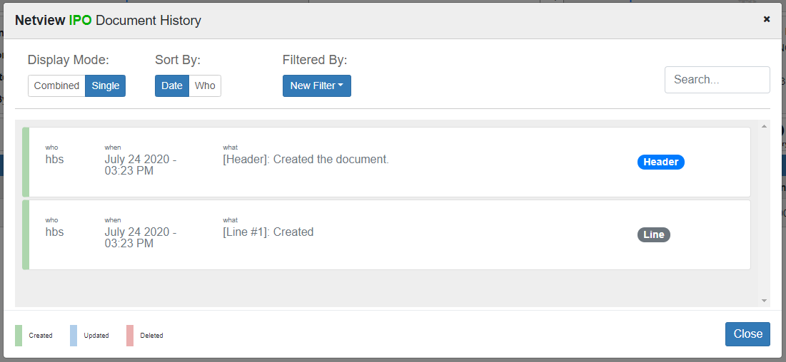

The list can be sorted by date (shows most recent action first) or by user (lists the actions alphabetically by their user, essentially grouping the actions together). The Filtered By feature is still available in this mode to help you look for specific actions, but the mode also provides a Search field to help you narrow the list down further.

Add Line: If you want to add a new line to the Requisition before converting it to a Purchase Order, click this button. The following screen will open:

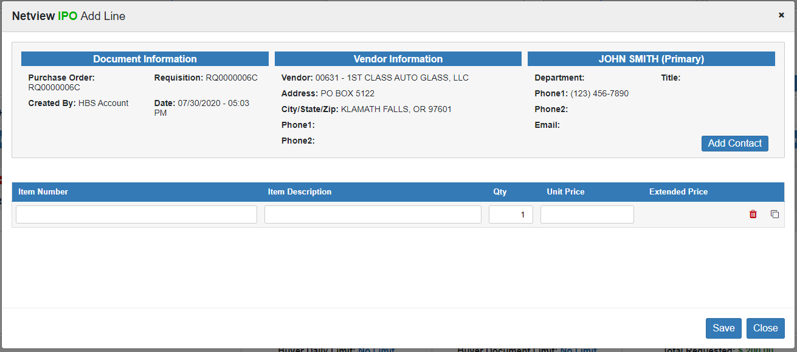

Fill in the line items the same way you did when originally creating the Requisition. You can create as many new lines here as needed. When you are done, click Save to add the new lines to the Requisition.

Void: If at any time you want to delete the entire Requisition, click this button. The following screen will appear:

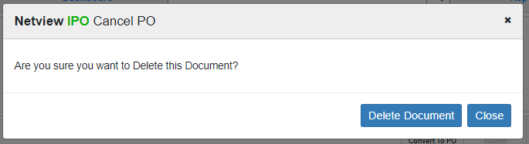

Click Delete Document to delete the Requisition. You will be returned to your default Dashboard, where the Requisition will no longer be present among the other active documents.

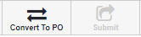

Converting/Submitting a Requisition: The final two Document Actions represent the next step in the PO process: changing the Requisition into an actual Purchase Order. How a Buyer does this depends on whether or not the document’s Total Requested Amount goes over one or both of their set limits, as that determines whether or not a user with an Approver role needs to look at the document.

Convert to PO: If the Total Requested Amount does not exceed the Buyer’s Daily and/or Document Limits, then this button will be active. Click on it to directly convert the Requisition into a Purchase Order. The following window will appear:

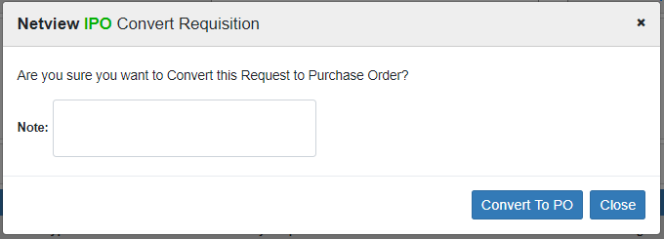

Add any notes you would like, then click Convert To PO. The document will automatically change into a Purchase Order:

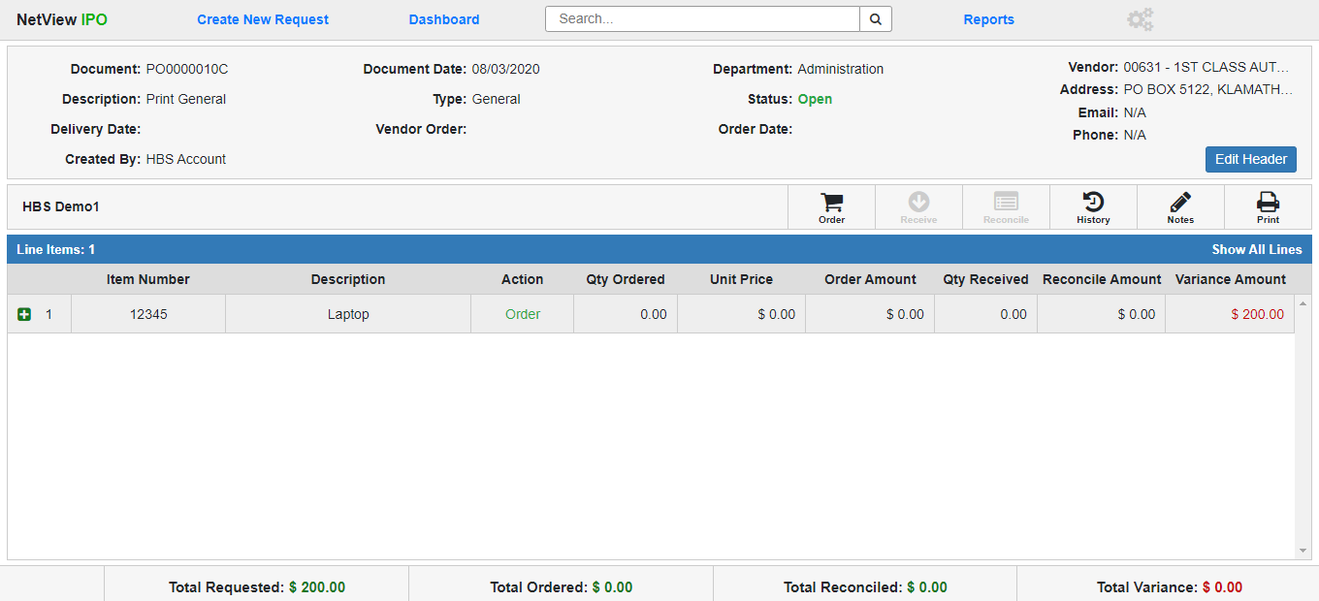

It will also now appear in the Open PO column on the Column Dashboard View, and have both a new PO document number and a status of Open on the List View.

At this point, the Buyer can no longer act on the document; their role in creating the Purchase Order is done.

Submit: If the Total Requested Amount exceeds the Buyer’s Daily and/or Document Limits, then this button will be active, indicating that the Requisition requires approval before it can become a Purchase Order. Click the button to submit the Requisition for approval. The following window will open:

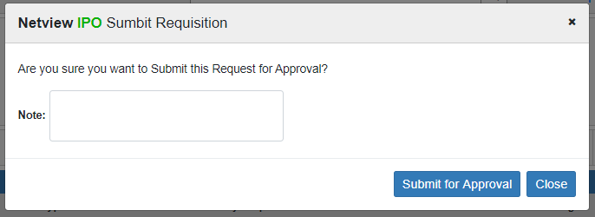

Add any notes you want and click Submit for Approval. This will convert the document directly into a Pending Approval Requisition (see image below) and send a notification via the Messaging feature to any Approvers with appropriate Approval Limits within the document’s location and department that they need to review the document. The system will also create a task in the users’ Tasks ActiveTile that will allow them to open the document directly from the tile on their Desktop.

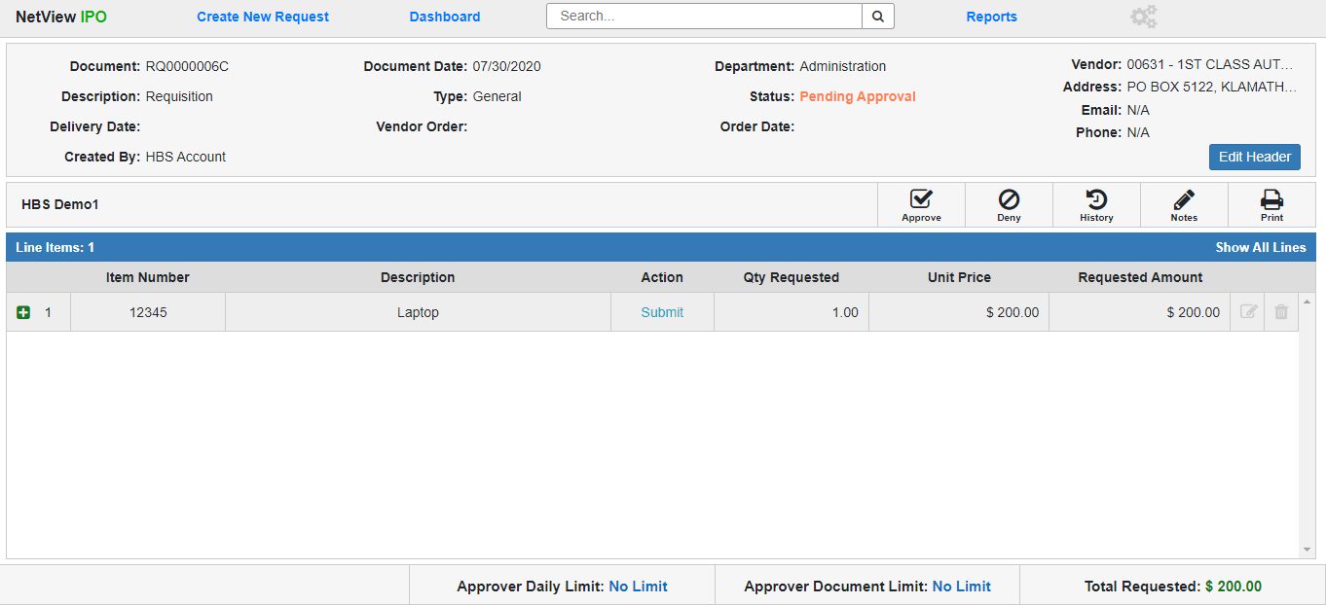

General Type Pending Approval Requisition: A General Type Requisition with a Pending Approval status has only a few, if significant, differences from an Open Requisition, which this section will highlight. Only users with an Approver role can act on a Pending Approval Requisition, and then only if that document’s Total Requested Amount is within their Approval Limits.

Pending Approval Header Changes: What fields appear in the Requisition Header and which ones can still be edited using the Edit Header feature will change when the document’s status becomes Pending Approval.

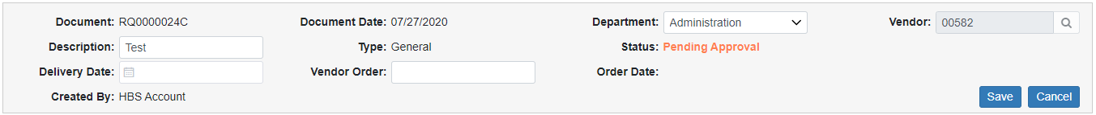

Document: The document number will not have changed and will still be display only.

Description: The document description will still be editable at this point.

Delivery Date: The delivery date will still be editable at this point.

Created By: The user created by will still be display only.

Document Date: The document date will still be display only.

Type: The document type will still be General and display only.

Vendor Order: This is a new, editable field added when the Requisition’s status becomes Pending Approval. It can hold the vendor-assigned order number for the purchase. If the number is known at this time, the Approver may enter it.

Department: The Approver can still edit the document’s department, but as with the Buyer, they can only change it to a department that they have permissions for as part of their role.

Status: The status will have changed to “Pending Approval” and still be display only.

Order Date: This is a new, editable field added when the Requisition’s status becomes Pending Approval. It can hold the date that you placed the actual order with the vendor. If the Approver knows the date at this time, they may enter it.

Vendor: The Approver will not be able to edit the vendor; this field will be disabled for editing.

Pending Approval Line Items: The line items’ displayed information will not change once the Requisition’s status is Pending Approval, on the main line or in the hidden Requisition Details section. However, once the Requisition is Pending Approval, the line items can no longer be changed or removed from the document—the Edit Line and Delete Line functions will be disabled.

Pending Approval Footer Changes: The document footer will still show the Requisition’s Total Requested Amount, but will instead show the Approver’s Daily and Document Limits. As with the Buyer, this keeps the Approver mindful of how many requests they can still approve before they hit their limits and, at least in the case of the Daily Limit, must wait until the next day to resume their role.

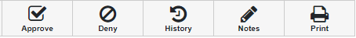

Pending Approval Document Actions: While the Notes, Print, and History actions will remain available, the other Document Actions will be replaced with the key actions that an Approver can take on a Pending Approval Requisition: Approve and Deny. After looking over the document, the Approver must decide whether or not to convert the Requisition into a Purchase Order, and their decision will determine which Document Action they need to use.

Deny a Requisition: If you as the Approver decide to deny the purchase request, click the Deny button. The following window will open:

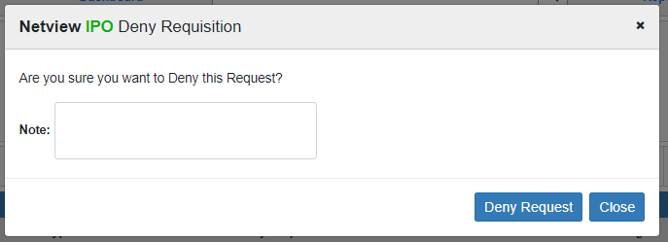

You can add an optional note explaining why you denied the request. Click Deny Request to finish the action. The Requisition will revert back to Open status, leaving it up to the Buyer to void the document if there is no chance the request will get approved.

Approve a Requisition: If you as the Approver decide to approve the Requisition to become a Purchase Order, click the Approve button. The following window will open:

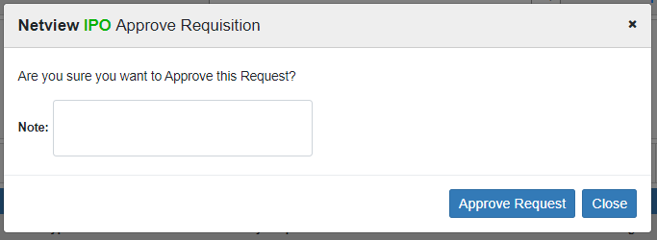

You can add an optional note to the action if desired. Click Approve Request to finish the action. The Requisition will automatically convert to a Purchase Order:



General Type Purchase Order: The General Type PO document largely cannot be edited, as by this point the details of the purchase have been approved and finalized. It will, however, be updated with new information as users with the appropriate roles act on the document. Only users with Ordering Clerk, Receiving Clerk, and/or A/P Clerk roles can act on an Open Purchase Order.

General PO Document Header: The document header for a General-Type Purchase Order is largely the same as on a Pending Approval Requisition, with some exceptions, including what can be edited with the Edit Header button.

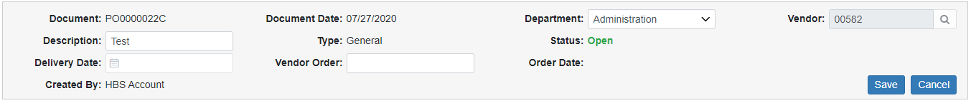

Document: The document now has a PO number instead of a Requisition number. The field is still display only.

Description: The document’s description can still be edited on a PO.

Delivery Date: The order’s delivery can still be edited on a PO.

Created By: This field is still display only.

Document Date: This field is still display only, and still shows the original date the request was created.

Type: This field still shows General and is still display only.

Vendor Order: This field holds the Vendor Order Number for the PO, which can still be edited on this screen, even after the number is entered during the Order step.

Department: Users with the proper roles can still edit the document’s department, but as with the Buyer and Approver, they can only change it to a department that they have permissions for as part of their role.

Status: The document’s status now reads Open, indicating it is an Open Purchase Order, and is still display only.

Order Date: This field holds the PO’s Order Date, which is display only, and will fill with the date entered by the Ordering Clerk when they conduct the Order step.

Vendor: The Vendor information cannot be changed once the document becomes a Purchase Order, and so is display only.

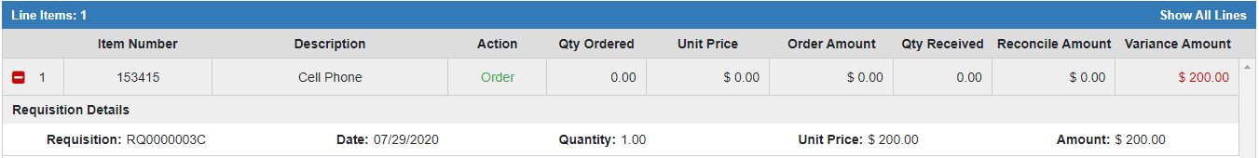

General Purchase Order Line Items: The main and expanded line items on a General Type PO are no longer editable by any user. However, the program will automatically update them with new information as users perform the Order, Receipt, and Reconcile steps on the document (done by the Ordering Clerk, Receiving Clerk, and A/P Clerk roles, respectively).

Main General PO Line Item:

- Line Number: The line item retains its line number from the original Requisition.
- Item Number: This holds the line’s item number.
- Description: This holds the item’s description.
- Action: This field shows the next action that needs to be performed on the line item. In the image above, it reads Order, meaning that the line has not yet been marked as actually ordered by an Ordering Clerk. This field will change to reflect the next action needed as users work on the PO.
- Qty Ordered: Once the Order step is performed on the line item, this field will fill with the quantity of the line item actually placed on order.
- Unit Price: Once the Order step is performed on the line item, this field will fill with the actual unit price of the line item listed on the order.
- Order Amount: Once the Order step is performed on the line item, this field will fill with the total amount of the line item actually placed on order (Ordered Unit Price x Qty Ordered).
- Qty Received: Once the Receive step is performed on the line item, this field will fill with the quantity of the item physically received by the dealership, per the Receiving Clerk.
- Reconcile Amount: Once the Reconcile step is performed on the line item, this field will fill with the total amount of the line item taken from the order’s invoice by the A/P Clerk.
- Variance Amount: This field will show the line’s variance amount, which will be the difference between the Reconcile Amount and the Order Amount. This will show if there was any discrepancy between what was originally stated as the line item’s cost and what was actually paid for the line item. While it will initially show the full value of the line, it will recalculate as the line is reconciled, showing the final Variance Amount once the line is completely reconciled. If there is no discrepancy, and the two amounts are the same, this field will show a zero which will be colored blue. Otherwise, the difference will appear as a red number, as in the image above.

Expanded General PO Line Item (Pre-Order): Before any actions are performed on the PO, the expanded line items will only show the Requisition Details section that appeared on the Requisition. More sections will be added to the expanded line as users perform actions on the PO, which will be covered later in the topic.

- Requisition: This field shows the Requisition number of the original request document.
- Date: This field shows the line item’s creation date. If the line was created during the initial document creation, this date will be the same as the Document Date.
- Quantity: This field shows the line item’s original requested quantity.
- Unit Price: This field shows the line item’s original requested unit price.
- Amount: This field shows the total amount originally requested for the line item (Unit Price x Quantity).

General Purchase Order Footer: The document footer on the Purchase Order shows the following total amounts for the document, which will calculate and update as users work on it:

Total Requested: This amount is the total amount of the original Requisition document, preserved to show any variance between the funds originally approved and how much the actual order ends up costing.

Total Ordered: This amount will fill in as the Ordering Clerk goes through the Order process and marks all the line items as either having been placed on order or not actually going to be ordered after all. Once the Order step is completed for the entire document, this value will show the total amount of the document that has actually been ordered, and thus what the A/P Clerk will eventually have to reconcile against once they obtain the line items’ invoices. As this value is not automatically assumed to be the same as the Total Requested, this gives the Ordering Clerk room to account for any unexpected changes that occurred when placing the order with the vendor, such as unavailable quantities, discounts, or price changes.

Total Reconciled: This amount will fill in as the A/P Clerk goes through the Reconcile process and inputs the accounting for all invoices connected to the Purchase Order. Once the process is completed, the amount will represent the total value of all the line items’ invoices, or the total amount actually paid for the order.

Total Variance: This amount will fill in as the A/P Clerk goes through the Reconcile process. Once all the line items are reconciled, this amount will represent the difference between the Total Ordered amount and the Total Reconciled amount, i.e. the difference between the order’s expected cost and its actual cost. If there is any value in this field other than “$0.00” by the time the A/P Clerk reconciles the document, then the document has a variance that the A/P Clerk will need to account for.

General Purchase Order Document Actions: The Document Actions for a Unit Purchase Order will activate or deactivate as users with the appropriate roles go through the required steps to complete the document: Order, Receive, and Reconcile. The Notes, Print, and History actions will always be active and will function as on a Requisition. However, the Print action will print the actual Purchase Order instead (sample image below):

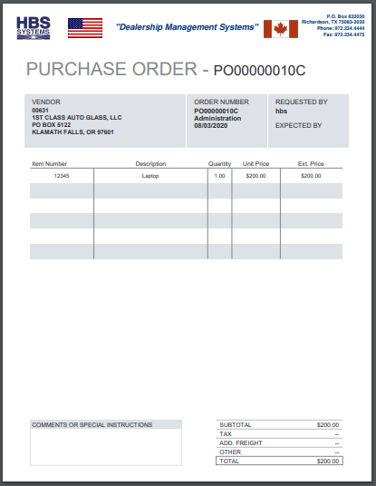



Ordering a General Purchase Order: The first action required on a General Purchase Order is the Order step, which can only be done by a user with the Ordering Clerk role. NOTE: If you have the Skip Order Step option turned on in the Settings screen, the program will automatically skip this step by assuming everything on the document was ordered exactly as it was requested, and go right to the Receive step.

To begin, the Ordering Clerk must click the Order Document Action. The following screen will open:

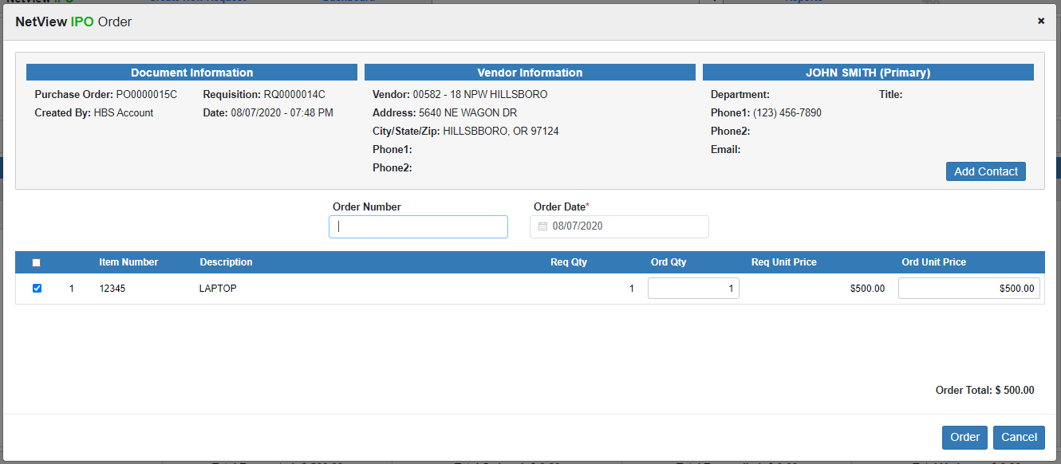

The screen will have the standard Header information as well as a running Order Total calculation in the bottom right-hand corner, as a preview of what will show in the Total Ordered field once you complete the step.

Order Number: Enter the order number you received from the vendor in this field, if available.

Order Date: Enter the order date in this field or select it from the calendar. It will default to the current date. This information is required for General POs.

General PO Order Grid Columns: This grid displays all the line items on the Purchase Order. Go through and input the necessary information from the vendor order to make sure the document will match the actual order.

Mark as Ordered: Put a check in this box to indicate that the line item is included on the order. If you ordered all the line items, you can check the Mark All box at the top of the column to automatically check this box for all the lines.

WARNING!!!: If you do not check this box for a line item, the line will be recorded as Not Ordered, preventing any user from receiving or reconciling it, as the program will assume you did not actually order the item. This could cause serious accounting issues later on if you did actually order the item.

Line Number: This column shows the line number.

Item Number: This column shows the item number for the line.

Description: This column shows the line item’s description

Req Qty: This column shows the original requested quantity of the item.

Order Qty: This field defaults to the Requested Quantity. If the quantity actually ordered is different, enter the new quantity here, though the value must be higher than zero (if the quantity will be zero, you should just make the line Not Ordered, as explained above).

Req Unit Price: This column shows the original requested unit price for the item.

Ord Unit Price: This field defaults to the Requested Unit Price. If the unit price as actually ordered is different, enter the new unit price value here. The Order Total below the grid will then recalculate based on the new value.

Once you have gone through every line item, click the Order button at the bottom of the screen. The program will return to the document screen and update it to reflect the Order step’s completion:

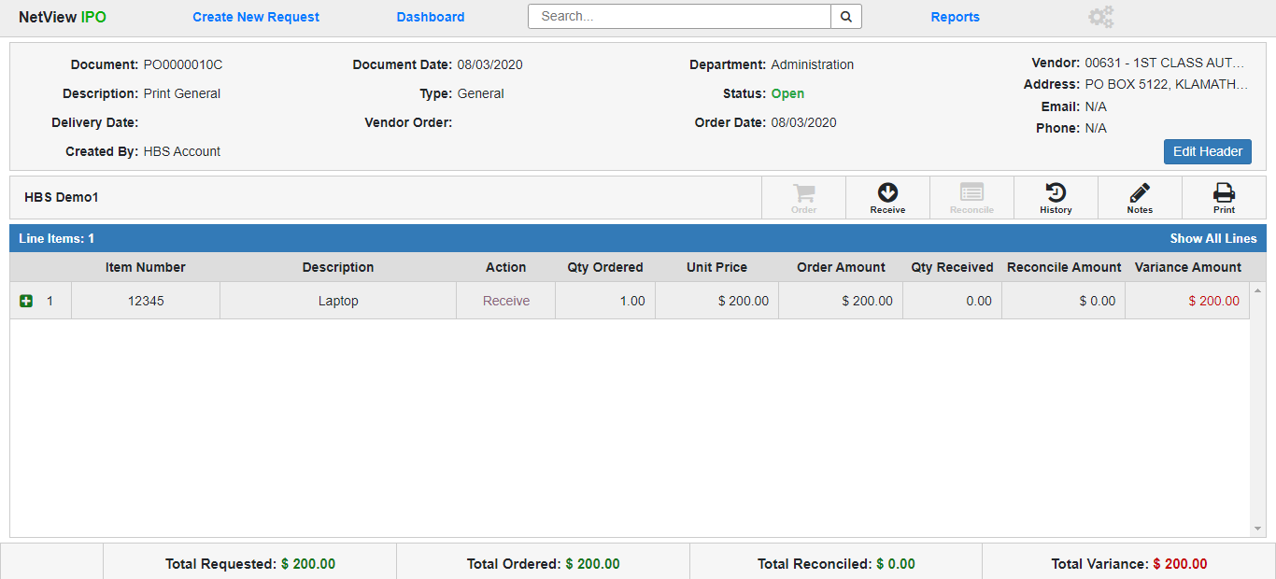

General Purchase Order Document (Post-Order): The General Purchase Order document will now show the following:

- The Order Date field in the Header will show the order date entered by the Ordering Clerk. If the Ordering Clerk entered an order number, that will appear in the Vendor Order field.
- The Order Document Action will be disabled, while the Receive action will be active.
- For each line item marked as Ordered, the Qty Ordered, Unit Price, and Order Amount fields will fill with the relevant information entered for the line by the Ordering Clerk. The Variance Amount field will also display the amount on the line that has yet to be reconciled, which at this point should be the full Ordered amount.
- All line items marked as Ordered will now show Receive in their Action field, indicating that the Receive step is the next action required for the lines.
- For each line item that was Not Ordered, the Qty Ordered, Unit Price, and Order Amount fields will show a zero value, and the line’s Action field will read Completed. The Line’s Variance Amount will fill with whatever value the Ordered Amount would have been had the line been Ordered.
- The Total Ordered field in the Footer will recalculate to show the total amount of all the Ordered line items, and the Total Variance will update to show the total amount of the document that needs to be reconciled, which at this point should be the same as the Total Ordered amount.

Receiving a General Purchase Order: The next step of the General PO comes after the physical items start arriving at your dealership. Once the first delivery arrives, the Receiving Clerk can begin the Receive step, which records what line items from the order have actually been delivered. NOTE: The step can be performed multiple times, to account for the order not getting delivered all at once.

To start, click the Receive Document Action. The following screen with the standard Header will appear:

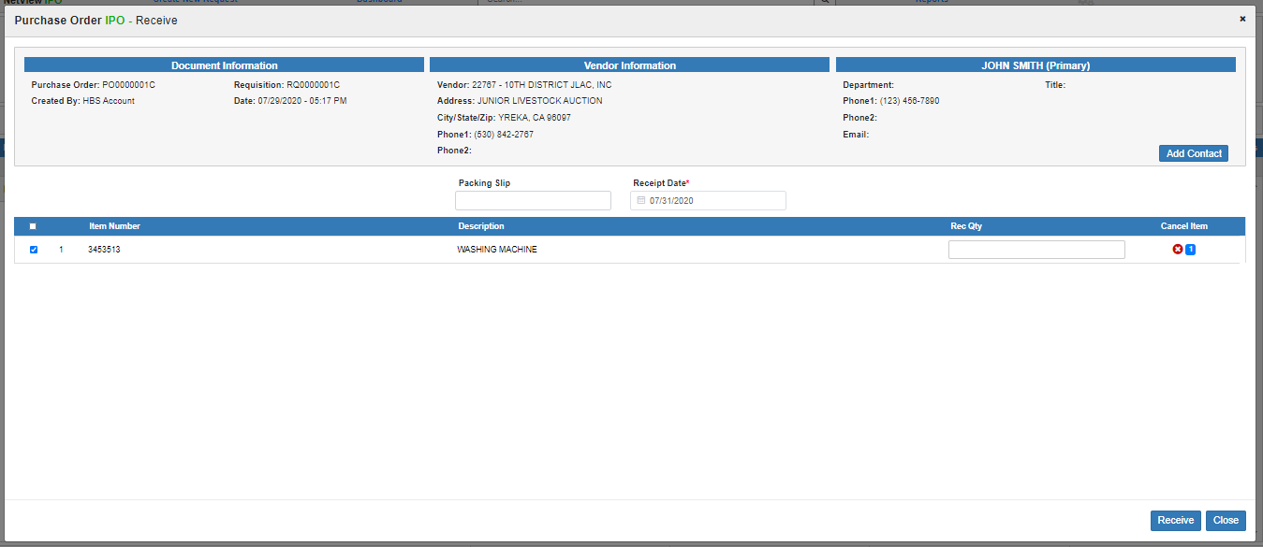

Packing Slip: Enter the packing slip number for the delivery, if available.

Receipt Date: Enter the packing slip receipt date or select it from the calendar. The date will default to the current date. This is a required field.

General PO Receive Line Grid: The grid lists all line items that have not yet been Received or Cancelled. Once a line’s quantity is fully Received or Cancelled, it will no longer appear in this grid.

Select as Received: Check the box next to each line item you want to mark as received on this date, with this packing slip number. NOTE: A line item will continue to appear in this screen until its entire quantity is received and/or cancelled.

Line Number: This column shows the line item’s number.

Item Number: This column shows the item number for the line.

Description: This column shows the line item’s description

Rec Qty: Enter the part of the line’s quantity that you received for this delivery. The blue indicator at the far end of the line will change to show you how much of the quantity remains. It will show “0” once you receive the full line item quantity.

Cancel Item: If you learn that any of the line item’s ordered quantity will not be delivered ever, use the red and white “x” icon in the Cancel Item column for that line item to cancel it. The blue number indicator will show you exactly what quantity will get canceled, as it shows the quantity that hasn’t yet arrived.

When you click the icon, the following window will appear:

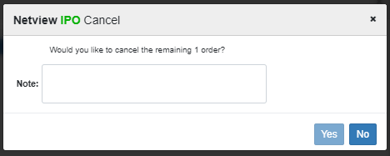

The message will ask if you want to cancel the remaining order quantity. Enter an explanation for why you are cancelling the receipt in the Note field. This is required in order to cancel the quantity. Once you have done so, the Yes button will activate. Click it to cancel the remaining quantity.

Once you have entered all quantities from the packing slip, click Receive at the bottom of the screen. The program will return to the document screen and update it to reflect the changes made during the step:

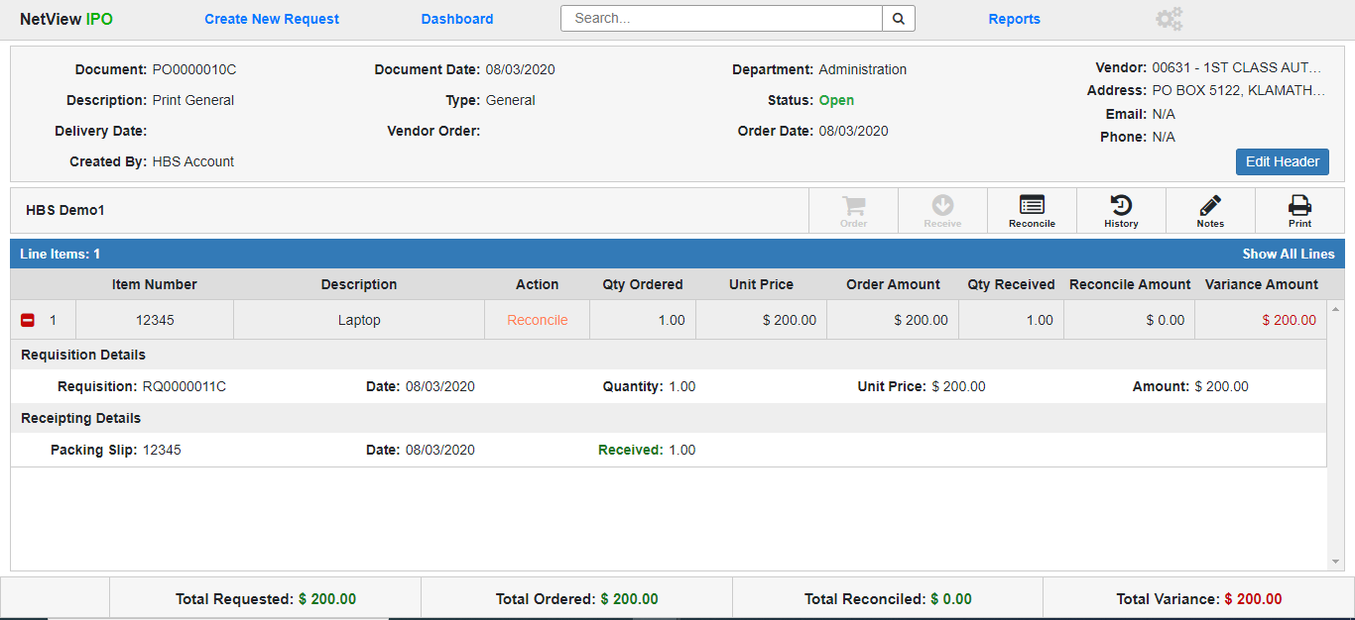

General Purchase Order Document (Post-Receive): The General Purchase Order document will now show the following:

- Receipting Details: When you expand the line items that have had items received, there will be a new Receipting Details section (see image above), which will hold a line for every Receive instance performed on the line (if done more than once). Each line will show the following information about the Receipt:
  - Packing Slip Number
  - Receipt Date
  - Quantity Received (will show in green) or Quantity Cancelled (will show in red)
- Once the line item’s full quantity gets received and/or cancelled, the line’s Action column will change to read “Reconcile,” indicating that the next step is to reconcile the line item’s accounting.
- Once at least one line item has been completely received, the Reconcile Document Action will activate, allowing you to start reconciling the received line if you are ready to do so (see the next section for more information).
- Once all the line items are received, the Receive Document Action will deactivate.

Reconcile a General Purchase Order: Reconcile is the final step needed to complete a Purchase Order, and must be performed by the A/P Clerk. It requires that the A/P Clerk have the vendor invoices for the delivered line items so they can record the invoice information in the system and export the invoice to Enter A/P Invoices (EAPI) for accounting. Once a line item has been received and the A/P Clerk has the invoice for that line item, begin by click the Reconcile button. The following screen will appear:

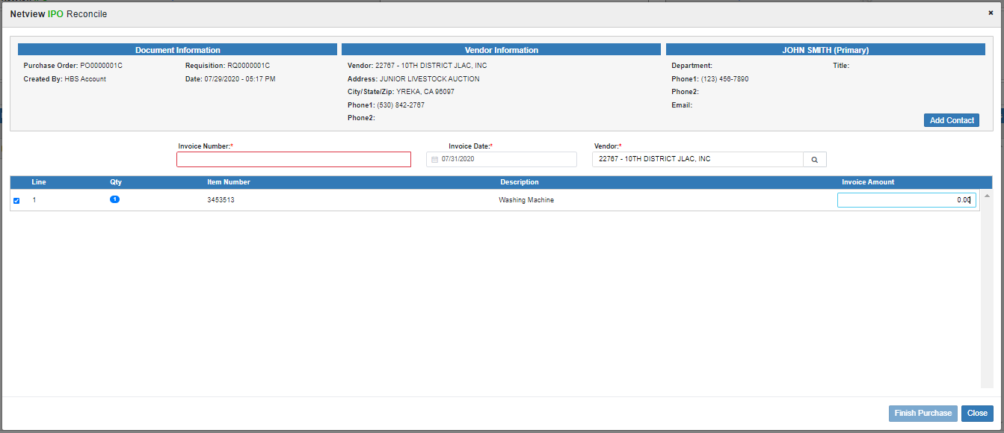

Invoice Number: Enter the invoice number you are reconciling against here. This is a required field.

Invoice Date: Enter the invoice date here. This is a required field. NOTE: The date must be in an open accounting month and not exceed your system's set future date limit. The program will not accept it otherwise.

Vendor: Enter the vendor number here or search for it using the Vendor Lookup. This is a required field. The field will default to the document vendor, but can be changed to another vendor if the invoice is from a different vendor. NOTE: The vendor must already be recorded in the A/P system in order for you to use it.

General PO Reconcile Grid—Main Columns: The grid will list all line items that have been received and thus ready to be reconciled to an invoice. For line items where the total quantity was not received all at once (received on separate packing slips/dates), the quantity will be divided into separate grid lines to account for each delivery requiring a separate invoice. Example: You order three of the same kind of laptop on the same line item, but one of the laptops has to be delivered separately and arrives three days late, after you have already performed the Receive step on the other two laptops, forcing you to receive it separately. That laptop will subsequently be listed on a different Reconcile line than the other two laptops, which will be kept together.

Select for Reconcile: Check this box to select the line item to be reconciled to this invoice. NOTE: You cannot finish the line’s accounting if you do not check this box.

Line: This column shows the line number.

Qty: This column shows the line item’s received quantity.

Item Number: This column shows the line’s item number.

Description: This column shows the item’s description.

Invoice Amount: Once you select the line to be reconciled, this field will activate. Enter the amount from the invoice that applies to the line item quantity. As mentioned, quantities from the same line item that were received separately will have separate lines in the grid to ensure they are invoiced correctly, in case they were listed on separate invoices due to having been delivered separately. You must fill this field in if you have selected the line quantity, as the Finish Purchase button will not activate otherwise.

Finish Purchase: Once you select the quantities that match the invoice number and fill in the required fields, this button will activate. Click it to export the invoice details to EAPI so that you can finish the in-system invoice accounting. NOTE: Any lines that are not selected will not be affected by clicking “Finish Purchase.”

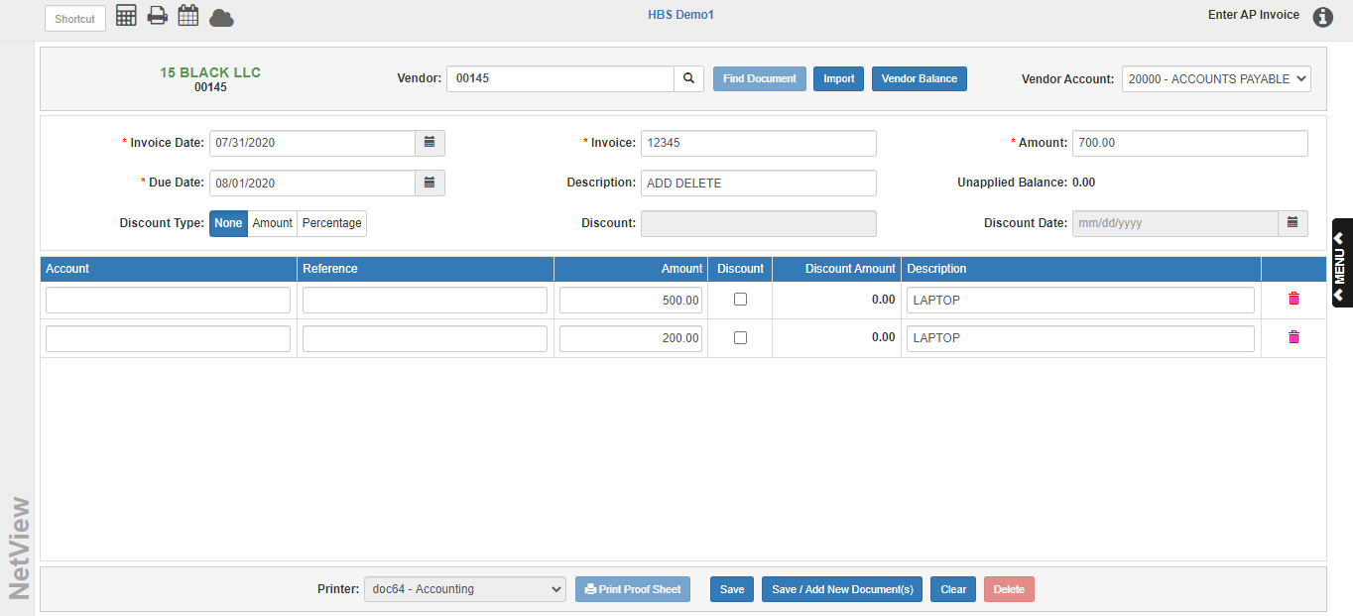

Finish inputting the invoice information as you would with any other A/P invoice and click Save. NOTE: If you leave this screen without completing and saving the invoice, the selected line items in IPO will not be reconciled. The Invoice Amount values you put into the Reconcile screen for the line items will remain stored in the screen for you to try again later, but you will have to go back, re-enter the invoice number/date/vendor, and re-export the invoice.

Once you complete the invoice and click Save, EAPI will close and return you to the main document screen in IPO:

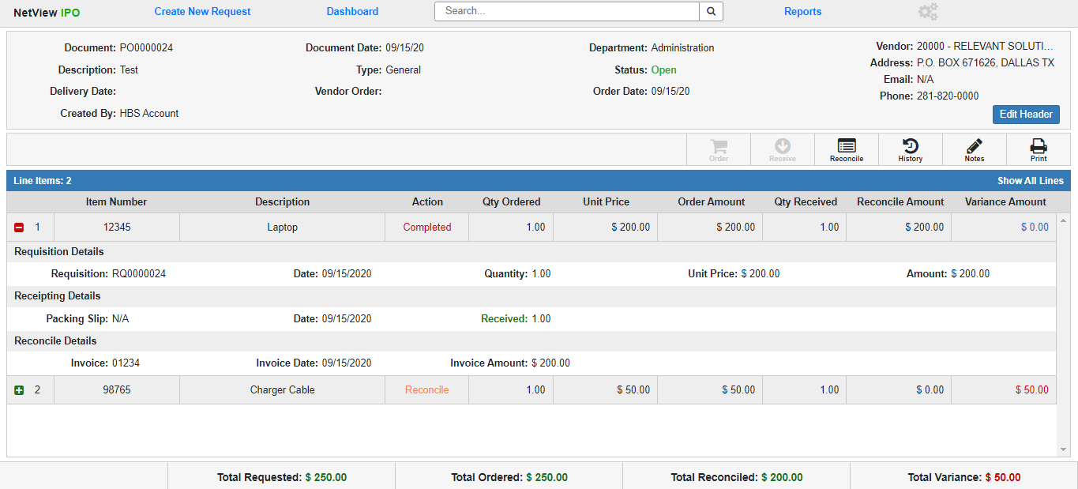

The following changes will have occurred:

- Reconcile Details: When you expand the Reconciled line items, there will be a new Reconcile Details section (see image above), which will show the following information about the invoice the line was reconciled against:
  - Invoice Number
  - Invoice Date
  - Invoice Amount
- The Reconciled line item(s) will now show Completed in their Action column, showing that no further action can be taken on those items.
- The Reconcile Amount field for each line item will fill with the Invoice Amount, and the Variance Amount will calculate based on the difference between it and the Ordered Amount.
- The Total Reconciled field in the Footer will recalculate to include the Reconciled Amounts of the Completed line items, and the Total Variance will recalculate based on the difference between it and the Total Ordered field.
- If any line items have not been reconciled yet, the Reconcile Document Action will remain active, and the Purchase Order will remain open.

Closing a Unit Purchase Order: Once all line items on the Purchase Order have been reconciled, the Purchase Order will automatically change its status to Closed and become a historical document.

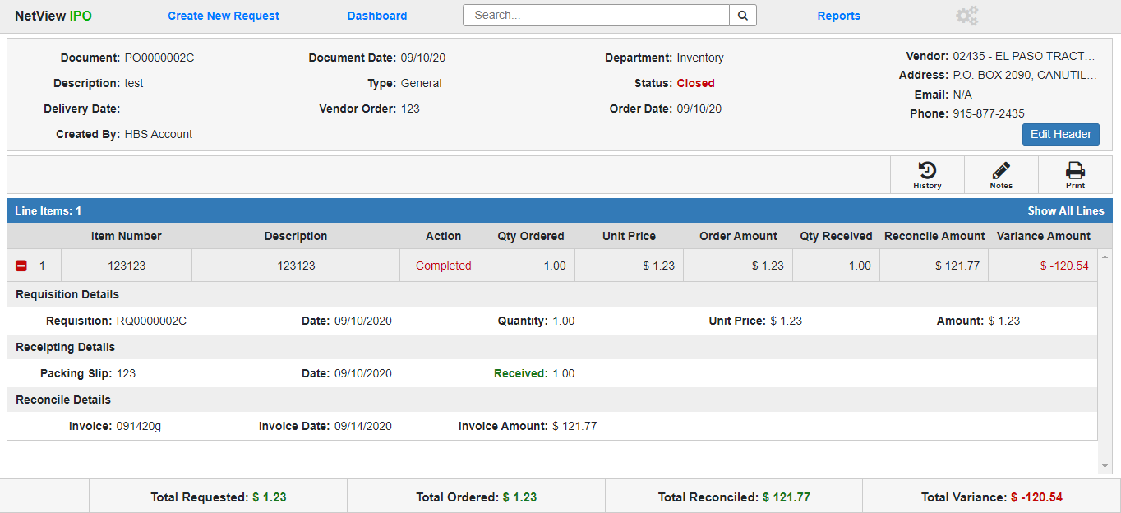

The following changes have occurred:

- All the line items now have a status of Completed.
- All Document Actions will disappear from the Toolbar except Notes, History, and Print, which can still be done by any user who can access the document.

